How to use VLAN tagging?

JCL currently uses ESXi as the hypervisor. VM ports are connected to port-groups on dvSwitch. In this networking configuration, ESXi drops frames with the standard VLAN tag (TPID = 0x8100).
If you configure VLAN tag to use TPID value != 0x8100, the frames will not be dropped. vMX can be configured to use custom TPID values.

Test Topology:
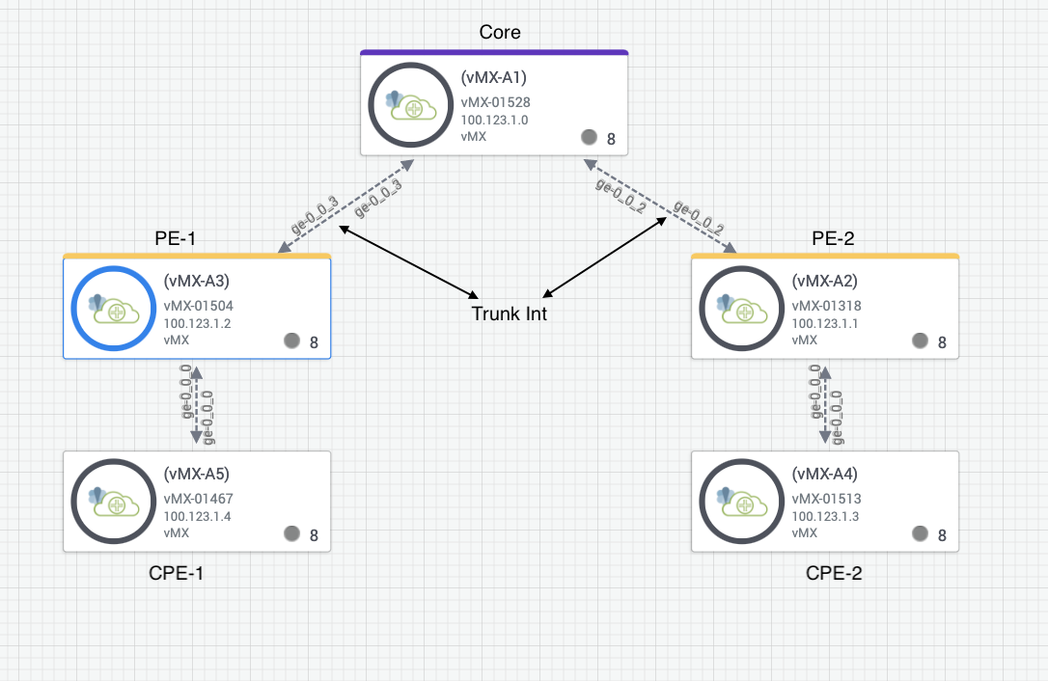
Example Configs:
Flexible VLAN Tagging on CPE device:
Config on vMX-A5:
set interfaces ge-0/0/0 flexible-vlan-tagging
set interfaces ge-0/0/0 gigether-options ethernet-switch-profile tag-protocol-id 0x9100
set interfaces ge-0/0/0 unit 100 vlan-tags outer 0x9100.100
set interfaces ge-0/0/0 unit 200 vlan-tags outer 0x9100.200
set interfaces ge-0/0/0 unit 100 family inet address 192.168.100.10/24

Config on vMX-A4:
set interfaces ge-0/0/0 flexible-vlan-tagging
set interfaces ge-0/0/0 gigether-options ethernet-switch-profile tag-protocol-id 0x9100
set interfaces ge-0/0/0 unit 100 vlan-tags outer 0x9100.100
set interfaces ge-0/0/0 unit 200 vlan-tags outer 0x9100.200
set interfaces ge-0/0/0 unit 100 family inet address 192.168.100.20/24
Config on Core:
Config on vMX-A1:
set interfaces ge-0/0/3 gigether-options ethernet-switch-profile tag-protocol-id 0x9100
set interfaces ge-0/0/2 gigether-options ethernet-switch-profile tag-protocol-id 0x9100
set interfaces ge-0/0/3 unit 100 vlan-tags outer 0x9100.100
set interfaces ge-0/0/3 unit 200 vlan-tags outer 0x9100.200
set interfaces ge-0/0/2 unit 100 vlan-tags outer 0x9100.100
set interfaces ge-0/0/2 unit 200 vlan-tags outer 0x9100.200
set interfaces ge-0/0/3 unit 0 family bridge interface-mode trunk
set interfaces ge-0/0/3 unit 0 family bridge vlan-id-list 100-300
set interfaces ge-0/0/2 unit 0 family bridge interface-mode trunk
set interfaces ge-0/0/2 unit 0 family bridge vlan-id-list 100-300
set bridge-domains bridge100 vlan-tags outer 0x9100.100
set bridge-domains bridge200 vlan-tags outer 0x9100.200

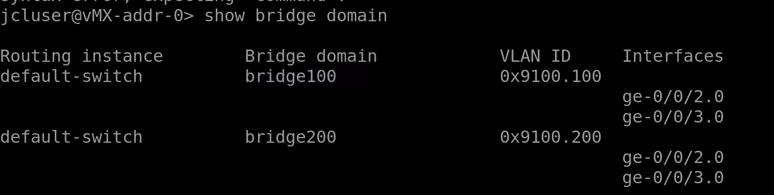
Bridge Domain configuration on PE devices.
Config on vMX-A3:
jcluser@vMX-addr-2> show configuration interfaces |display set
set interfaces ge-0/0/0 vlan-tagging
set interfaces ge-0/0/0 mtu 9192
set interfaces ge-0/0/0 encapsulation extended-vlan-bridge
set interfaces ge-0/0/0 gigether-options ethernet-switch-profile tag-protocol-id 0x9100
set interfaces ge-0/0/0 unit 100 vlan-tags outer 0x9100.100
set interfaces ge-0/0/0 unit 200 vlan-tags outer 0x9100.200
set interfaces ge-0/0/3 gigether-options ethernet-switch-profile tag-protocol-id 0x9100
set interfaces ge-0/0/3 unit 0 family bridge interface-mode trunk
set interfaces ge-0/0/3 unit 0 family bridge vlan-id-list 100-300

jcluser@vMX-addr-2> show configuration bridge-domains |display set
set bridge-domains bridge100 vlan-tags outer 0x9100.100
set bridge-domains bridge100 interface ge-0/0/0.100
set bridge-domains bridge200 vlan-tags outer 0x9100.200
set bridge-domains bridge200 interface ge-0/0/0.200

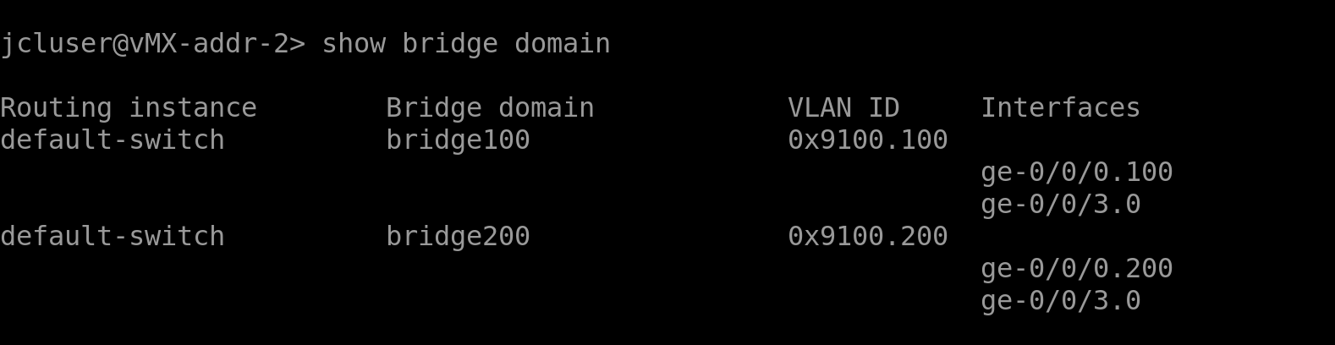
Note: Similar config to be done for vMX-A2.
Please note that this workaround may work only for vMX and not for vSRX

